FINAL REPORT
BANA 6670
PRESCRIPTIVE ANALYTICS WITH OPTIMIZATION

Portfolio Optimization with Financial Data

Submitted By
Chandana Karnaty

Submitted to
Prof. Fang Fang

TABLE OF CONTENTS

- Literature review
- Objective of your final project
- The formulation of each optimization model (at least two different models: detailing the decision variables, objective function, and constraints).
- Data sources and preprocessing steps.
- Descriptions of algorithms used
- Optimization results and comparisons across models, presented with clear visualizations and interpretations.
- A final summary of your findings, comparisons, and the rationale for your selected portfolio.

Literature Review:
The process of choosing asset weights that balance risk and forecast return using past financial data, such as stock prices or returns, is known as portfolio optimization.
I used three models-
Mean- Variance: Minimizes variance for a given return.
Sharpe Ratio: Identifies the most efficient portfolio relative to risk-free.
CvaR: Optimization minimizes the expected loss beyond the Value at Risk.

INTRODUCTION:
Used the portfolio optimization with latest financial data of five years of the companies Apple, Amazon, Google, Microsoft and tesla.
Used the three models- Mean variance, Sharpe Ratio and CvaR to use past financial data for the analysis and development of effective investment portfolios. These models have been chosen because they present different approaches for understanding as well as managing the risk-return trade-off, providing a comprehensive structure for quantitative portfolio optimization.

FORMULATION OF EACH OPTIMIZATION MODEL:
- Mean- Variance
Decision Variables:
$x_{i}$= total wealth invested in asset $i$
$n$= total number of assets
Objective Function:
$$\text{Minimize }σ_{p}^{2}=x^{T}Σx$$
Constraints:
Portfolio expected return ≥ target:
$$\sum_{i=1}^{n}{}μ_{i}x_{i}≥R_{\text{target}}$$
- Sharpe Ratio:
Decision Variables:
$x_{i}$= fraction of wealth in asset $i$
Objective Function:
$$\text{Minimize }ζ+\frac{1}{(1-α)S}\sum_{s=1}^{S}{}max⁡(0,L_{s}-ζ)$$
Constraints:
$$\sum_{i=1}^{n}{}x_{i}=1$$

DATA SOURCES AND PREPROCESSING STEPS:
Data sources:
The financial data used in the project was from Yahoo Finance using the python yfinance library in google colab.
The daily adjusted and closing prices are downloaded for last 5 years from October 10, 2020 to October 10, 2025.
Preprocessing steps:
Choose "Adjusted Close" prices to account for dividends and splits.
Remove rows with missing values to produce a clean and aligned time series.
Calculate daily returns as percentage change in adjusted prices.
Calculating the mean daily return vector and return covariance matrix, which utilize inputs to portfolio optimization models.

DESCRIPTION OF ALGORITHMS USED:
- Global minimum variance (GMV):
Minimize the total portfolio risk
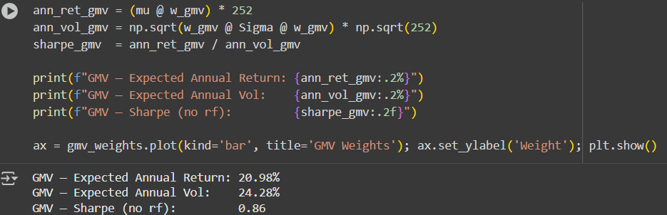
This algorithm finds portfolio with the lowest risk without any expected returns.

- Maximum return portfolio:
Maximize expected return while keeping the risk

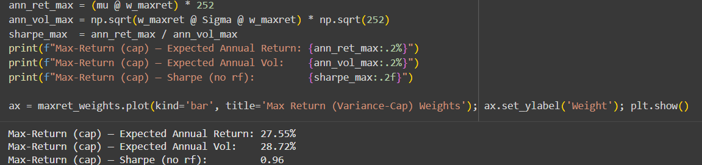

- Maximum sharpe ratio:
Risk adjusted return

It is the convex problem by maximizing the sharpe ratio, it tries to find out the most efficient portfolio.

OPTIMIZATION RESULTS AND COMPARISSIONS:
Portfolio model | Exp. Return% | Volatility% | Sharpe ratio
GMV | 20.98 | 24.28 | 0.86
Max return | 27.55 | 28.72 | 0.96
Max sharpe | 26.57 | 27.61 | 0.96

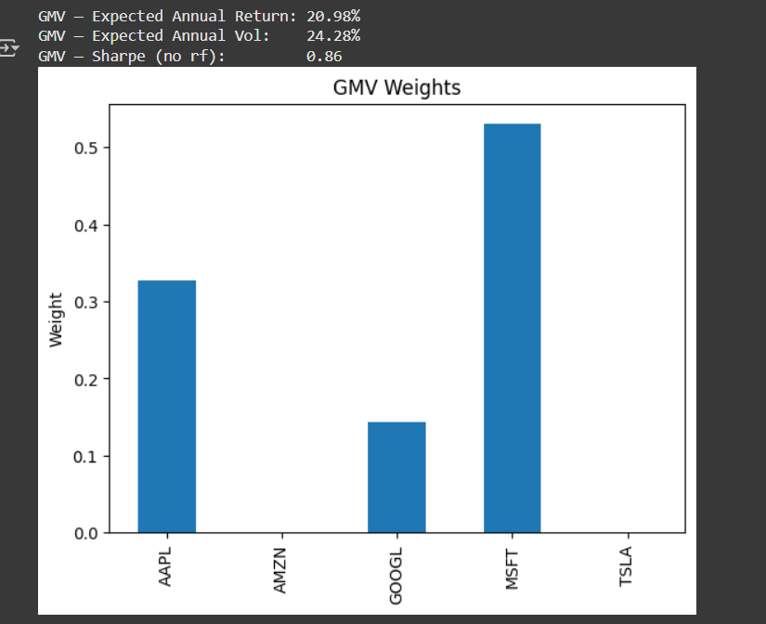
The bar chat indicates the GMV weights are high at Microsoft, second apple, google and 0 to amazon and tesla.

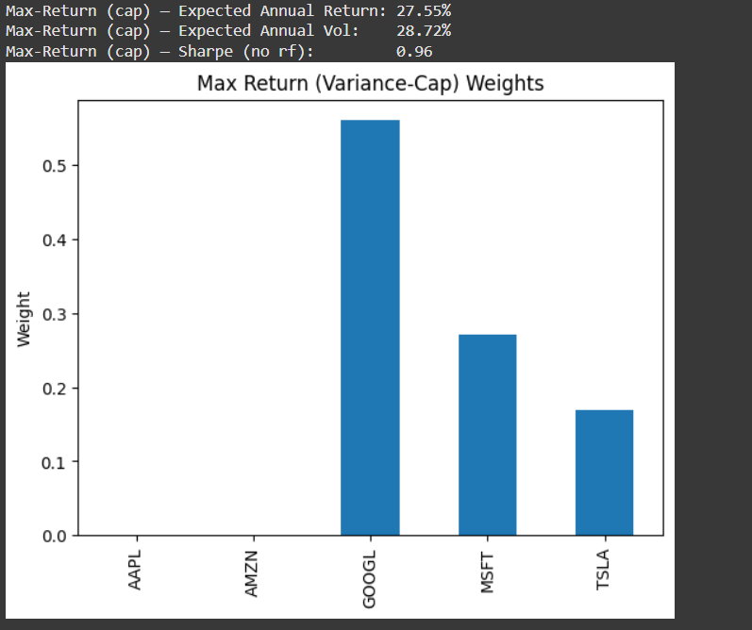

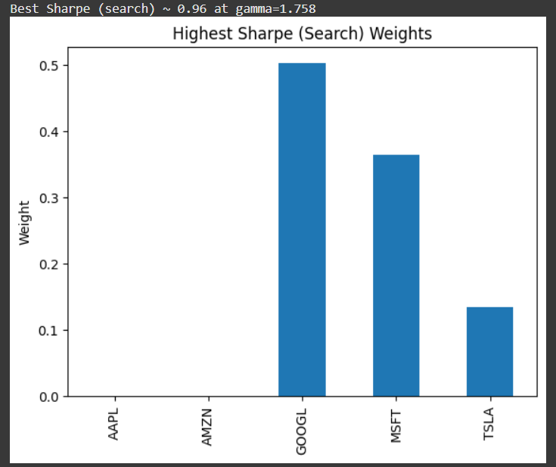

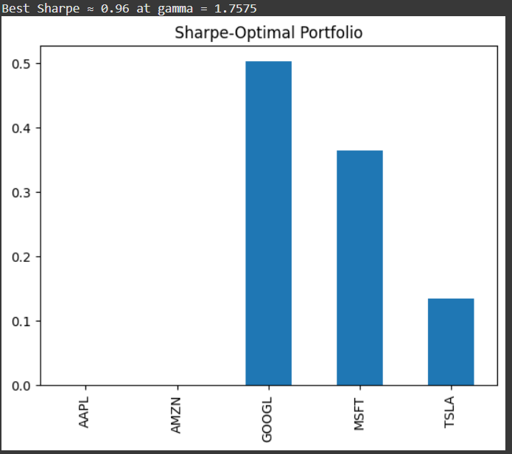

From the above bar chart, we see that google has more sharpe-optimal portfolio then the Microsoft, tesla and least are the apple and amazon.

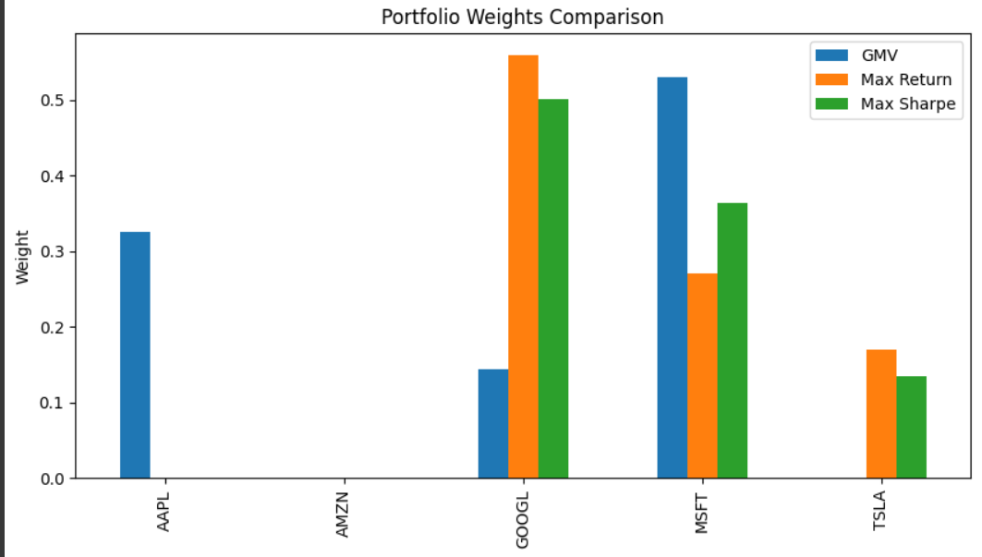
From the above portfolio weights comparison, we see that google has the highest max return, then Microsoft and tesla. Amazon doesn’t have any max return, sharpe ratio. Max ratio portfolio is the most efficient and useful for investors.
FINAL SUMMARY:
This project has three portfolio optimization models-Global Minimum Variance (GMV), Maximum Return (with risk cap), and Maximum Sharpe Ratio on real historical financial data for five major technology companies: Apple, Alphabet, Microsoft, Tesla, and Amazon. The Global Minimum Variance portfolio has the lowest volatility, making it an ideal choice for especially cautious investors. However, the estimated return was low. The Maximum Return portfolio had the highest estimated return but also the most volatility. The Maximum Sharpe Ratio portfolio earned the highest risk-adjusted return by balancing risk and reward. The maximum sharpe ratio method produces the optimal portfolio to findings. It provides the most effective risk return tradeoff and makes it ideal for investors for long-term growth with lowest risk.

